Task 1: Home Network Diagram

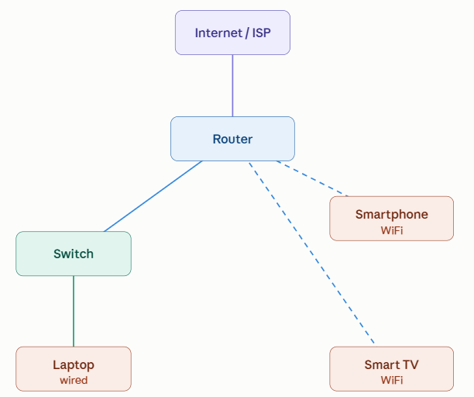
- Wi-Fi Router: Connects via WAN port to the ISP modem/Fiber line;
hosts a built-in DHCP server and translates IP addresses via NAT.
- Smartphone: Associates wirelessly over 2.4 GHz / 5 GHz radio bands
directly to the router's integrated access point.
- Network Switch: Expands the router’s physical LAN ports via a
hardwired Cat6 trunk link.
- Laptop & Smart TV: Connect via dedicated RJ-45 Ethernet patch cables
directly to switch ports for stable, low-latency transmission.

Task 2: Network device comparison

Network Device | Primary Layer | Function / Core Characteristics | Real-World Use Case & App Example
Router | Layer 3 (Network) | Routes packets between different networks (LAN to WAN) based on IP addresses; performs NAT and assigns IP addresses via DHCP. | Directing your YouTube or Netflix video requests from your home subnet out across the internet to the streaming provider's edge servers.
Switch | Layer 2 (Data Link) | Forwards data frames within a local network using hardware MAC address tables; prevents collisions and ensures dedicated port bandwidth. | Connecting multiple gaming consoles or PCs in an internet café or LAN gaming room for low-ping matches in Valorant or CS:GO.
Wireless Access Point (WAP) | Layer 2 / Layer 1 | Converts wired Ethernet network signals into radio waves (Wi-Fi) to extend wireless local area network (WLAN) coverage. | Deploying ceiling-mounted units in college libraries or cafes so users can browse Instagram and Flipkart without dead zones.
Hub | Layer 1 (Physical) | Broadcasts incoming data to all connected ports, regardless of destination (older, largely obsolete). | Legacy shared-network setups — mostly replaced by switches today since it wastes bandwidth by sending data everywhere.
Task 3: Data Flow Scenario — Ordering on Zomato

- Smartphone to Access Point (Wireless Transmission): I open the Zomato app on my phone and search for food. My phone sends the request through the Access Point (Wi-Fi).
- When tap "Place Order" in the Zomato app, phone packages the order parameters into data frames and transmits them as radio frequency signals to the Wireless Access Point (integrated inside home Wi-Fi gateway).
- Access Point to Switch (Medium Conversion & Bridging): If a Switch is used in the network, it transfers data between wired devices.
- The Access Point demodulates the radio waves into Ethernet frames and passes them to the internal Switch module. The switch inspects the destination MAC address to ensure the frame reaches the router interface without broadcasting it unnecessarily to other devices like Smart TV.
- Switch to Router (Routing & NAT): The request reaches the Router, which sends it to the Internet through the ISP.
- The Router strips the Data Link frame headers to read the destination IP address of Zomato’s API gateway. It replaces your phone's private IP address (e.g., 192.168.1.15) with your ISP-assigned public IP address via Network Address Translation (NAT).
- Router to WAN: The request reaches the Zomato server, which processes it and sends the results back to my phone through the same path.
- The router pushes the IP packet across the WAN gateway onto your ISP's network, which routes it across core Fiber backbones to Zomato’s cloud servers to confirm your payment and restaurant order.

Task 4: Connecting a Gaming PC Far from the Wi-Fi Router

Solution 1: Powerline Ethernet Adapters
- How It Works: A Powerline kit consists of two wall-plug adapters that use your home’s existing copper electrical wiring as a high-speed data transmission medium.
- Setup:
  - Plug Adapter A into a wall socket near your router and connect it to a router LAN port with an Ethernet cable.
  - Plug Adapter B into the wall socket in your room next to the gaming PC.
  - Run an Ethernet cable from Adapter B directly into the PC's RJ-45 NIC.
- Benefit: Provides a stable, hardwired connection without drilling holes or running lengthy Cat6 cables across rooms.
Solution 2: Wi-Fi Extender / Mesh Node with an Ethernet Port (Client / Bridge Mode)
- How It Works: A wireless range extender or mesh satellite receives the Wi-Fi signal from your main router over the air and acts as a wireless bridge, converting the wireless link into a wired interface via its built-in RJ-45 jack.
- Setup:
  - Place the extender in or near your gaming room where it can still receive a strong Wi-Fi signal from the main router.
  - Connect an Ethernet cable from the extender’s LAN/Ethernet port directly into the back of your gaming PC.
- Benefit: Enables an Ethernet-only device to join your home network wirelessly without requiring an internal Wi-Fi PCIe card or USB Wi-Fi dongle.

